Equip pic 1

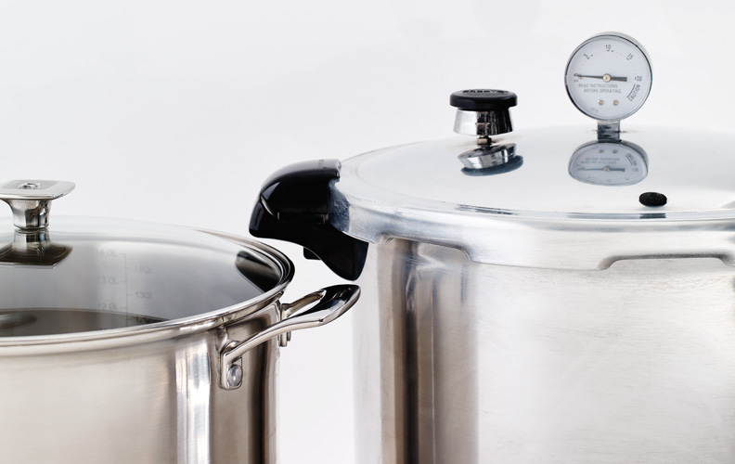

<https://i.imgur.com/idfbW63.jpg>

Equip pic 2

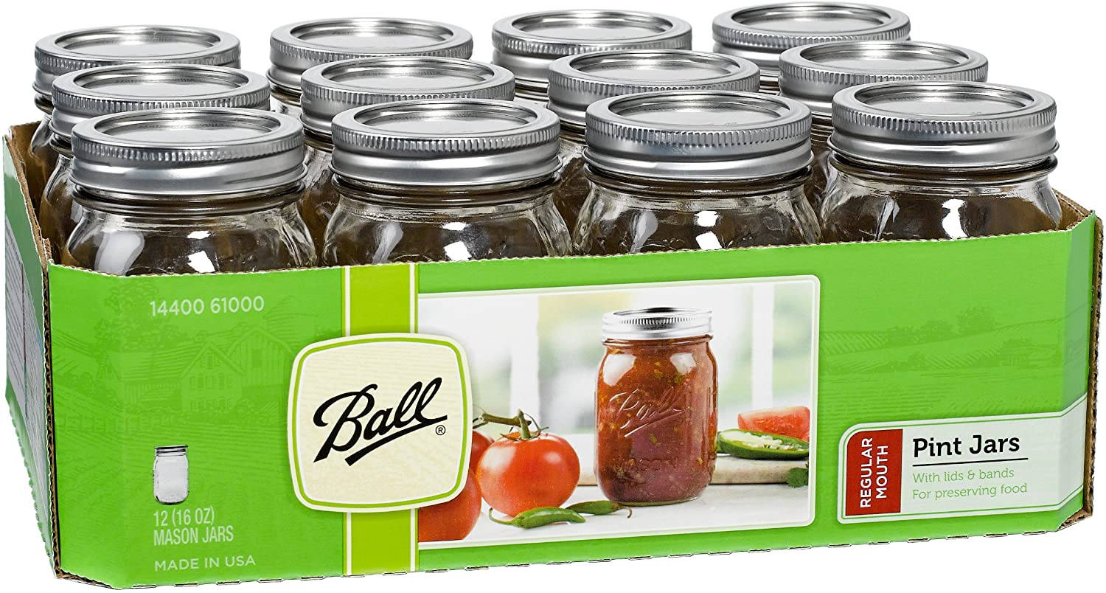

https://i.imgur.com/tSgKHgr.jpg

Equip pic 3

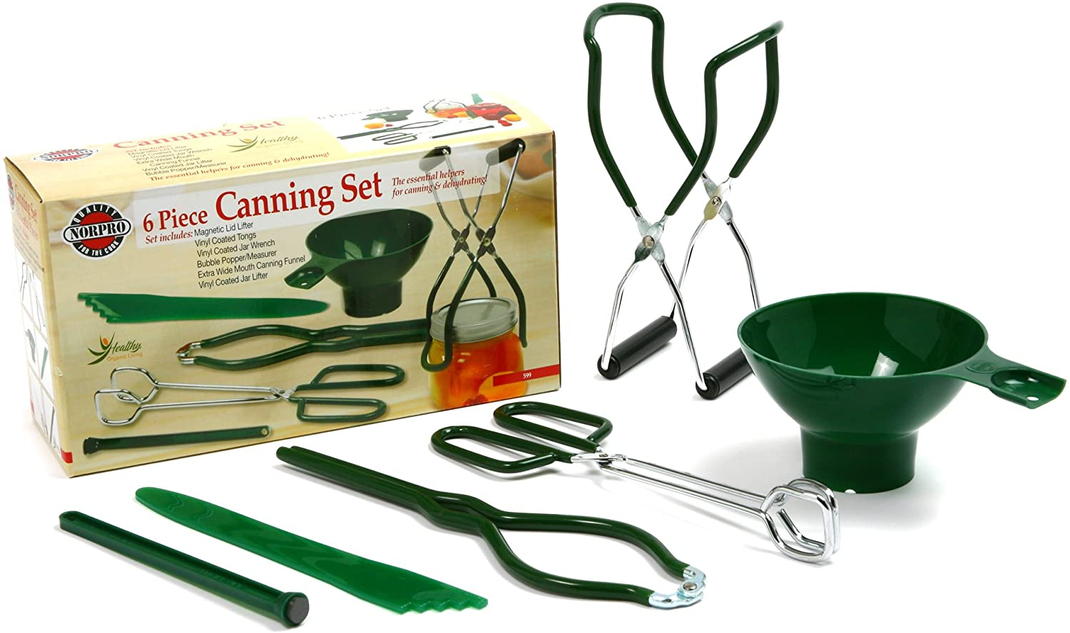

https://i.imgur.com/PLtK0F3.jpg